**Question 1:** On your own hard disk, try to find some file that were deled in the past and recover them. Are you able to use them?

**Answer:** Using a tool for mac called DiskDrill I was able to scan the machine for deleted files. I had one of the lab sheets (shown below) in the hope of restoring it.

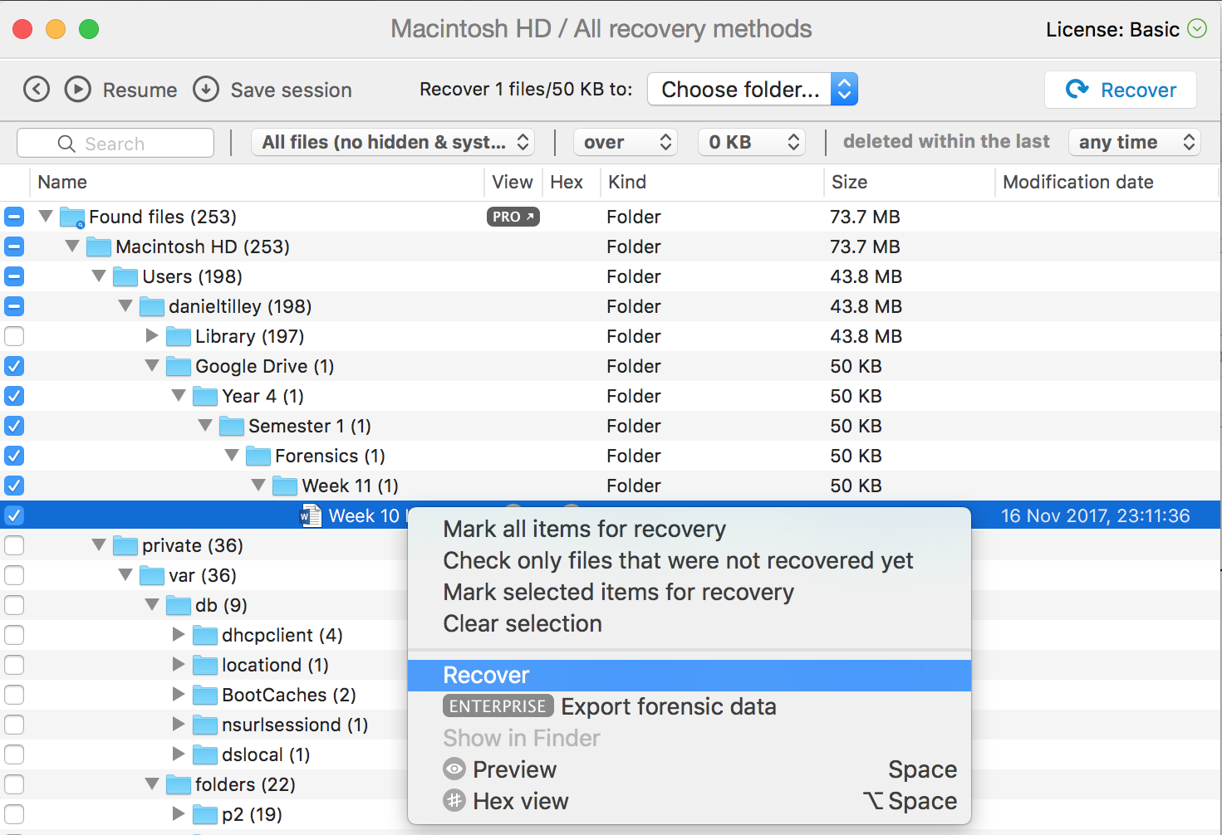

Once I clicked restore, the file was placed back in the original directory and was able to be viewed and edited.



**Question 2:** Write a brief policy, 3 or 4 paragraphs, that defines an employer’s responsibility to securing information in the organisation.

**Answer:** Security regarding the company’s customers and business affairs is of the utmost importance. Under no circumstances should any information be given to, or should any discussion take place with, external parties regarding the affairs of the company, any of its affiliates or customers without prior consent from a person of authority.

A duty of care applies to all files, documents, papers and other information relating to the company under an employee’s control. Documents or any item belonging to the company or which contain information about the company may not be removed from the premise at any time without proper advance authorisation. All documents, or items which either belong to the company or contain information about the company must be returned upon request or upon termination of employment to the appropriate individual.

It is the responsibility of all staff members to conduct their business in full compliance with all applicable laws and regulations. All staff members are required to familiarise themselves with the companies general policies and principles and with the particular compliance requirements that relate to a staff members work area. At all times, a staff member must be aware of all relevant security, internet and e-mail policies also.

Under the Data Protection Acts 1988 and 2003, staff members are required to ensure the privacy of data held both on a computer and on a manual files. A staff member should only access information which they legitimately require to carry out their job role.

Any breach of procedures may be regarded as gross misconduct and could result in serious disciplinary action or dismissal. If a staff member becomes aware of a breach of confidentiality of any of the companies polices, they must report the breach to the appropriate figure of authority, if appropriate.